IP ROUTING AND ROUTING PROTOCOLS

Q1. Draw a simple network diagram showing three devices (like your phone, a friend's laptop, and a smart TV) connected through a router, and label the IP addresses for each device and the router's interfaces.
Ans.
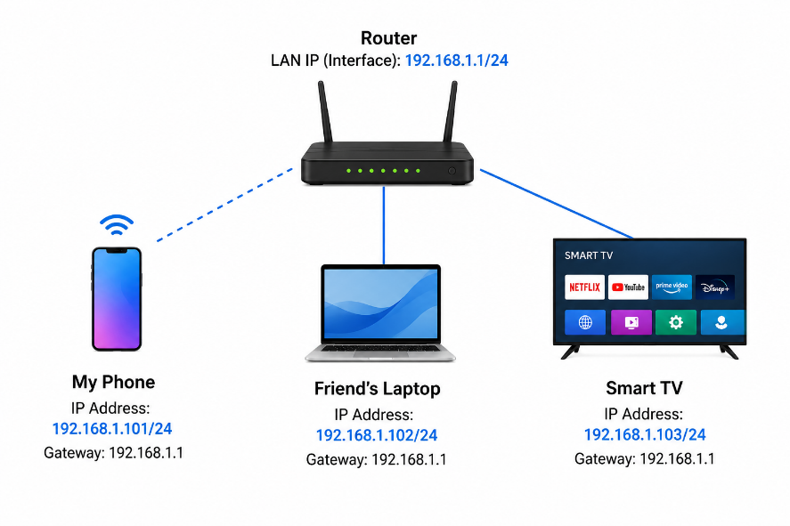
Q2. Simulate manual IP routing by writing a step-by-step explanation of how a packet would travel from your laptop to a friend's computer in a different subnet, including which router(s) it passes through and how the routing decision is made. Hint: Use made-up IP addresses and show the routing table entries that would be checked at each hop.
Ans. Step 1: Laptop creates the packet
Source IP: 192.168.1.10
Destination IP: 10.20.30.50
Since the destination is on another subnet, the laptop sends the packet to its default gateway R1 (192.168.1.1).
Step 2: R1 checks its routing table
10.20.30.0/24 → 172.16.0.2
R1 finds the matching route and forwards the packet to R2 (172.16.0.2).
Step 3: R2 checks its routing table
10.20.30.0/24 → Directly Connected
R2 knows the friend's computer is on its local network, so it sends the packet to 10.20.30.50.
Step 4: Packet reaches the friend's computer
Laptop → R1 → R2 → Friend's Computer
Routing decision: Each router checks the destination IP and selects the best matching route from its routing table.

Q3. Create a routing table for a fictional Zomato-style delivery network with three branches in different cities, each on a different subnet. Specify the network address, subnet mask, next hop, and interface for each route.
Ans. Fictional Zomato-Style Delivery Network Routing Table
Network Address | Subnet Mask | Next Hop | Interface
192.168.10.0 | 255.255.255.0 | Directly Connected | Delhi-LAN
192.168.20.0 | 255.255.255.0 | 10.0.0.2 | Mumbai-WAN
192.168.30.0 | 255.255.255.0 | 10.0.0.3 | Bengaluru-WAN

Branches:
- Delhi: 192.168.10.0/24
- Mumbai: 192.168.20.0/24
- Bengaluru: 192.168.30.0/24
- The next hop tells the router where to forward packets, while the interface specifies which network connection to use.
Q4. Compare static routing and dynamic routing protocols (like RIP or OSPF) by listing 3 pros and 3 cons of each, using examples from real-world apps or services you use (e.g., how a food delivery app might benefit from dynamic routing).
Ans. Static Routing
3 Pros:
- Simple for small networks – Easy to configure when there are only a few routers.
- No routing overhead – Routers don't exchange routing information.
- Predictable and secure – Routes don't change automatically.
3 Cons:
- Manual work – Every route must be configured by an administrator.
- Poor scalability – Difficult to manage hundreds of routers.
- No automatic recovery – If a link fails, the route may stop working until someone changes it.
Example: A small restaurant might have one router with a fixed route to its billing server.
Dynamic Routing
3 Pros:
- Automatic updates – Routers learn routes automatically.
- Handles failures – OSPF can find another path if a network link goes down.
- Scales well – Suitable for large networks with many routers.
3 Cons:
- More complex – Requires knowledge of protocols such as RIP or OSPF.
- Uses network resources – Routers exchange routing information.
- More processing required – Routers must calculate and maintain routes.
- Real-world example: A food-delivery app such as Zomato may have servers in multiple locations. With OSPF, routers can automatically choose another available path if one network connection fails.
In short:
Static = manually configured, simple, good for small networks.
Dynamic = automatic, flexible, better for large networks.
Q5. Use ChatGPT or another AI tool to generate a sample configuration for setting up OSPF routing between two routers, then explain in your own words what each configuration line does. Hint: Paste the AI-generated config and annotate each part with a short description.
Ans. OSPF Configuration
R1:
router OSPF 1
network 192.168.1.0 0.0.0.255 area 0
network 10.0.0.0 0.0.0.3 area 0
R2:
router OSPF 1
network 192.168.2.0 0.0.0.255 area 0
network 10.0.0.0 0.0.0.3 area 0
Explanation:
- router OSPF 1 → Starts OSPF.
- network ... area 0 → Advertises that network through OSPF.
- area 0 → OSPF backbone area.
- 10.0.0.0/30 → Network connecting R1 and R2.
- Result: R1 and R2 automatically learn each other's networks without manually adding routes.

